What is Sketch Up?

My PBL project is 3D design with Sketch Up application. Sketch Up was developed by google and quickly it became a popular free 3D design application. Recently it was sold to another company and it's not free anymore but TEA provides free to all public schools in Texas.
What can you do with the free version of Sketch up?
- Easily create a 3D drawing that approximate real life objects.
- Make models that are almost as detailed as you have time to make them.
- Share models through 3D warehouse, export images in many different formats, or export movies of your work.
Interface | Toolbars > View
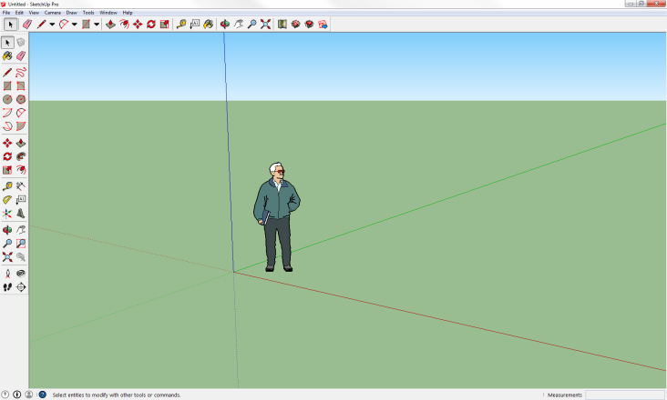 | 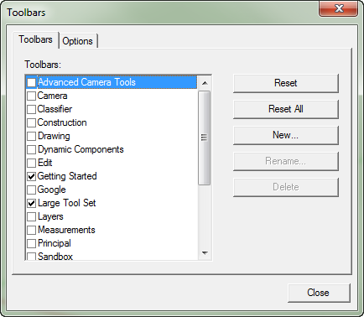
Sample 1 | Sample 2
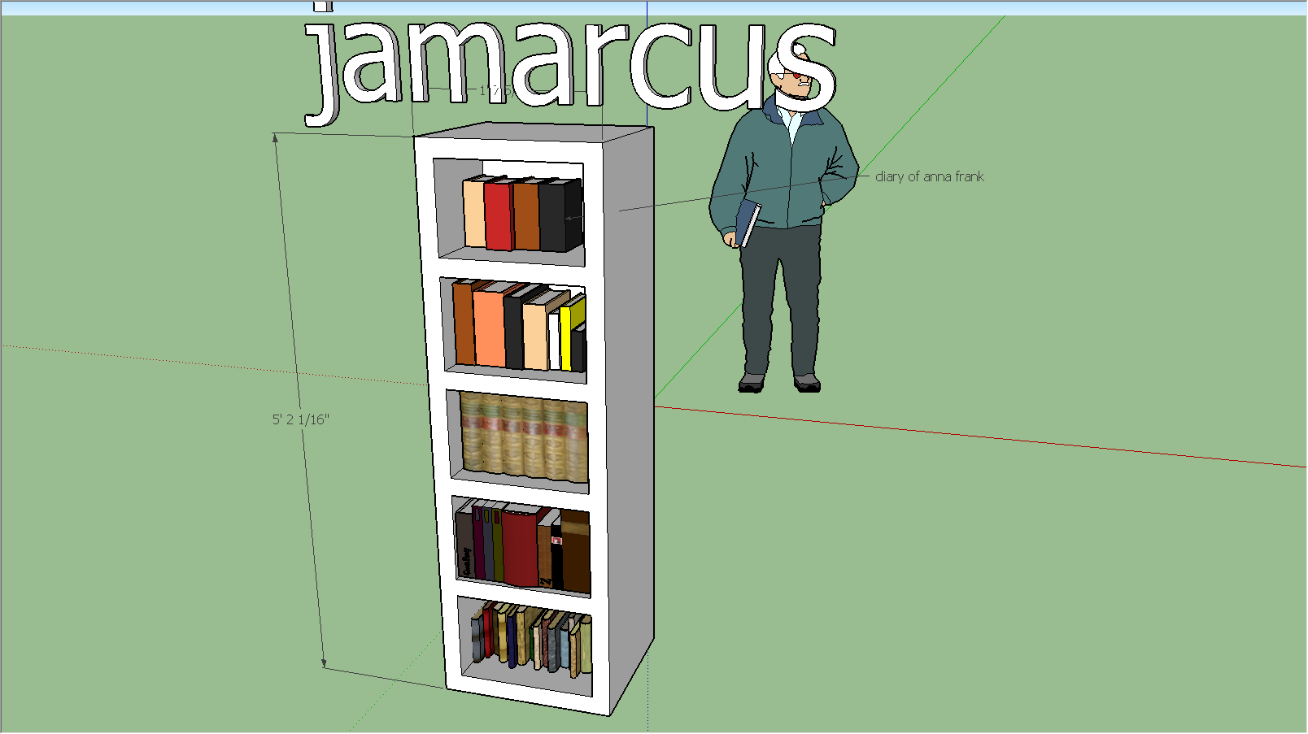 | 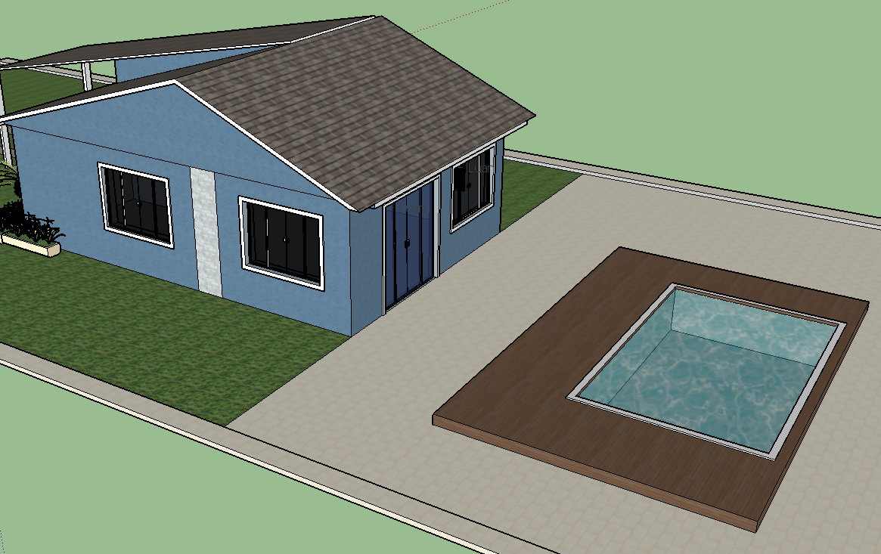
My Video | My Website

